Shabbos Stories for
chanukah 5780

Volume 11, Issue 15 25 Kislev/ December 23, 2019
Printed L’illuy nishmas Nechama bas R’ Noach, a”h

For a free subscription, please forward your request to keren18@juno.com

A Story of Valor
For Hanukkah

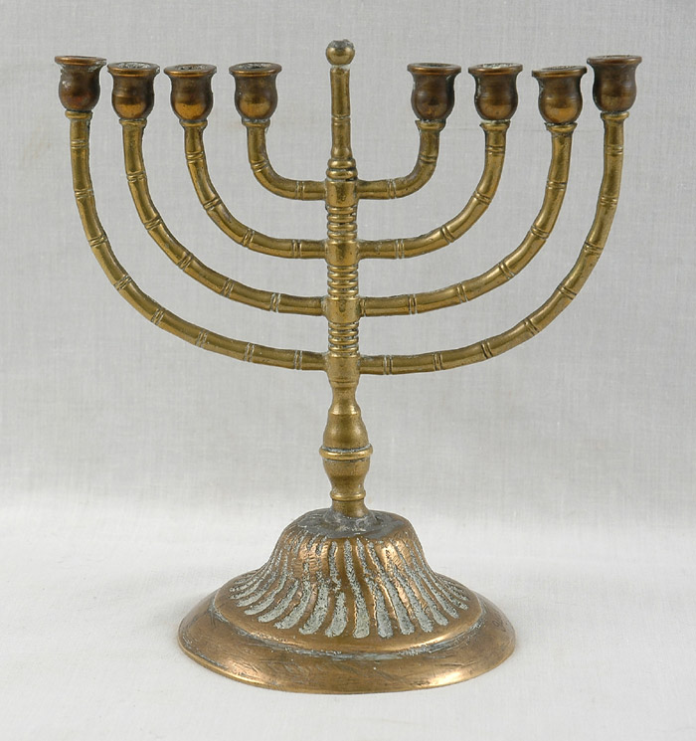
The Hanukkah Menorah that Willy Tal received as a gift for his Bar Mitzvah in Amsterdam in 1935.

The holiday of Hanukkah has come to symbolize the struggle for national revival that Zionism represents. The light of the eight days has become the light of the Jewish state in the land of Israel and the valor of the Maccabees has become a symbol of the national spirit.

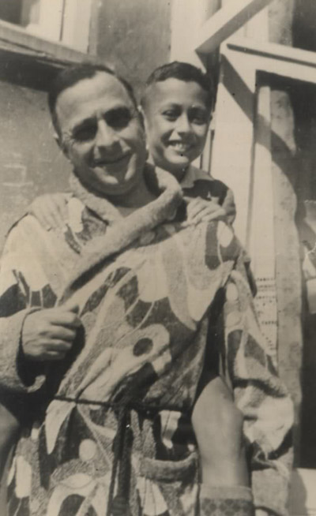
Willy Tal with his father Felix, 1935

With the approach of Hanukkah, we have chosen to highlight the heroism of Willy Tal, whose Menorah was donated to the artifacts collection in October.
Willy Tal was born in Amsterdam in September 1922, the second child of Felix & Greta Tal, a brother to Florry. With the outbreak of war Willy found work with the Jewish Council as a male nurse in the Jewish Hospital for the mentally disturbed “Het Apeldoornse-bos”. This gave him a temporary reprieve from deportation.
On January 21st 1943, by order of Eichmann, in conjunction with Gemmeker, the Kommandant of Westerbork transit camp, some 900 mentally disturbed patients and 500 hospital staff were deported to Auschwitz. Though there was advanced warning of the round up, and some 100 workers went into hiding, Willy refused to abandon his patients and was sent with them to Auschwitz. Willy was murdered there on the 30th of April, 1943.
Willy’s father, Felix, who had understood what the future held upon the occupation of Holland, transferred the family’s valuables, documents and family albums to a room that he rented in Amsterdam. Among these was the Hanukkah Menorah that his son Willy had received as a Bar Mitzva present.
Felix and Greta survived the war in hiding in Amsterdam. At the end of the war Felix collected the hidden family property. In 1947, Greta, her daughter Florry and her son-in-law Eli Asscher immigrated to Israel and brought the Menorah with them.
The Hanukkah Menorah was donated in October 2008 by Florry Asscher to the Yad Vashem’s Artifacts Collection as a final keepsake of her brother Willy who was murdered in Auschwitz.

Reprinted from the website of Yad Vashem. The World Holocaust Remembrance Center in Jerusalem, Israel.

Alexander the Great and the First Miracle of Hanukka
By Rabbi Yosef Bitton

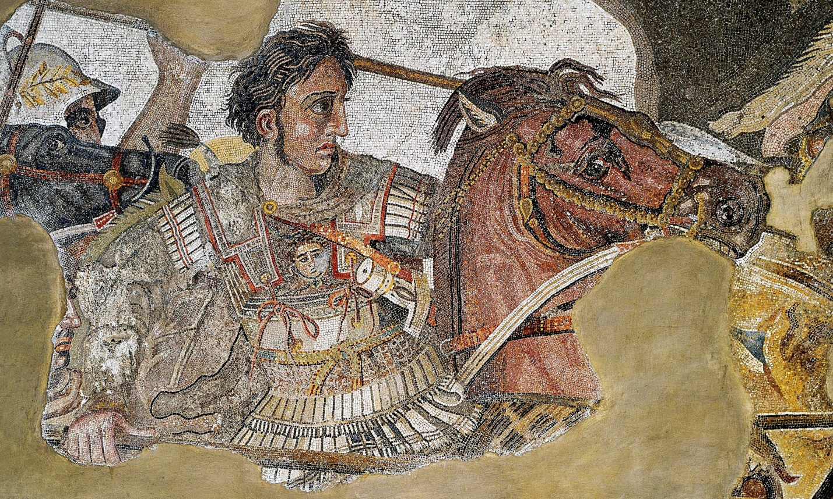

For the Greeks, and for the Romans a few centuries later, it was intellectually (or psychologically) impossible to understand Judaism. They could not conceive that we Jews believe in (and especially that "obey") an invisible G-d: "what is not seen, does not exist", they reasoned.
They also found incomprehensible the Jews' refusal to accept that other gods could coexist with our G-d. What's wrong with placing a statue of my god next to your G-d? Pagan deities did not demand exclusivity of cult! Why should Jews demand it?
Furthermore, in the polytheistic mentality when a people was defeated it meant "that their gods turned out to be less powerful than the gods of the victors." The defeated peoples accepted -pacifically or forcefully- the superiority of the conquering gods, and embrace them, in addition to their own local idols! A new pantheon with a combination of local and foreign deities represented the most diplomatic way to survive the military defeat.
As we can see, the coexistence of several gods was normal at that time. And the Jews' refusal to accept the gods of neighboring peoples was seen as a sign of their arrogance or intolerance.
Only once we understand this, that is, what must have crossed the mind of Alexander the Great when the Jews rejected his request, we are able to better appreciate the magnitude of the miracle that took place in that moment. Now, why is that this great miracle is not better known? I think because it is not something that happened, but something that should have happened and providentially did not happen. That makes it more abstract, elusive, and difficult to identify.
Something else: Like every emperor, Alexander demanded from each people of his Empire to send soldiers to serve in his army. The Jews formed their own battalion that served in the ranks of the Greek army. Alexander ordered that Jewish soldiers be allowed to keep their religion (Kashrut, Shabbat, etc.) while serving in their ranks.
There is also documentation that shows that Alexander the Great instructed his generals to excuse the Jewish soldiers from participating in the construction of a pagan temple in Babylon (E. Bickerman), an act forbidden for Jews.
And a letter was found where Alexander asks to deliver a special Kosher oil to the Jewish soldiers in Antioquia, since they could not use the common oil (ta-me).
Alexander the Great accepted the non-negotiable principles of the Jewish people, and during his short lifetime he became the protector of the Jews of his empire.

Reprinted from the November 27, 2018 Halakha of the Day email from the Shehebar Sephardic Center.

Story #1095

Discovered in Alabama
From the desk of Yerachmiel Tilles
editor@ascentofsafed.com

A young man named Avraham ("Avrumel") Greenbaum lost his entire family in the Holocaust. After the war, he came to America and wanted nothing to do with Judaism. He changed his name to Aaron Green, moved to Alabama and married a woman there, who, miraculously, was Jewish.
The day his oldest son Jeffrey turned thirteen, they were not going to celebrate his bar mitzvah. Instead, Aaron decided to recognize the day by taking Jeffrey to the mall and buying him anything he wanted there.

Jeffrey’s Eye Caught Something
In an Antique Shop
When they went into a big electronics store and were browsing, Jeffrey's eye caught something in an antique shop across the way. He was mesmerized. He couldn't take his eyes off what he had seen.
He told his father, "I don't want anything from the electronics store. I want to go across to the antique shop." When they got there, the boy pointed to an old wooden menorah and said, "That's what I want for my bar-mitzvah."
His father couldn't believe it. He was letting his child buy anything he wanted in the whole mall and this is what he was choosing? He tried to talk him out of it, but couldn't.

Shopowner Doesn’t Want
To Sell the Menorah
Aaron asked the shop-owner the price of the menorah. To his surprise, the man replied "Sorry, that's not for sale."
Aaron said, "What do you mean? This is a store." He offered a lot of money for it.
Again the owner refused, this time explaining, "I found out the history of this menorah. A man constructed it during the war and it took him months to gather the wood. It survived, but he did not. It's going to be a collector's item. It's not for sale."
Meanwhile, Jeffrey kept telling his father, "That's what I want. All I want is the menorah." So Aaron Green kept offering more money until the owner finally agreed to sell.
The boy was so excited. He took the menorah up to his room and played with it every day. One day the parents heard a crash from Jeffrey's room. They ran upstairs and saw the menorah shattered to pieces. The father yelled at his son for being so careless, as he paid so much money for it.
Afterwards, Aaron felt bad about his reaction. He suggested to his son, "Let's try to glue it back together."

Father Notices a Piece of Paper Wedged Inside
While holding one of the pieces, the father noticed a piece of paper wedged inside. He pulled it out and started reading. Tears welled up in his eyes and soon after he fainted.
His family threw water on him and revived him. "What happened?", they asked.
He replied, "Let me read you this letter. It was written in Yiddish, so I'll translate.
"To whoever finds this menorah, I want you to know that I constructed it not knowing if I would ever have the opportunity to light it. Who knows if I will live till Chanukah to see it being kindled? In all probability, going through this war, I will not. But if Providence brings this menorah to your hands, you who are reading this letter, promise me you will light it for me and for us, my family, and those who gave their lives to serve G-d Al-mighty."
Aaron Green then looked up at his family and, in a choked-up voice with tears still in his eyes, said, "The letter is signed by my father."
They were all speechless. That family recognized the Divine Providence involved and they returned to living their lives according to Torah and mitzvot. How could they not! The hand of G-d was undeniable, taking a menorah from Europe and bringing it back to the family in a remote mall in Alabama, inspiring them to return to Torah-true Judaism.
~~~~~~~~~~~~~~~~~~~~~~~~
Source: Adapted by Yerachmiel Tilles from a submission by Chayim Berkowitz of Tsfat (formerly of Miami), who received it from Yosef Hurwitz, whose son-in-law and daughter, Rabbi Yosef and Mrs. Binah Goldwasser, are the co-directors of "Chabad of Mobile" and heard it from the family.
[Author's concluding paragraph:] Chanukah means to re-dedicate. It's a time to rededicate ourselves and come closer to the Creator.

Reprinted from the 5779/1918 Chanukah email of KabbalaOnline.org, a project of Ascent of Safed.
In Holland, One of the World’s Most Expensive Hanukkah Menorahs Hides in Plain Sight
By Cnaan Liphshiz

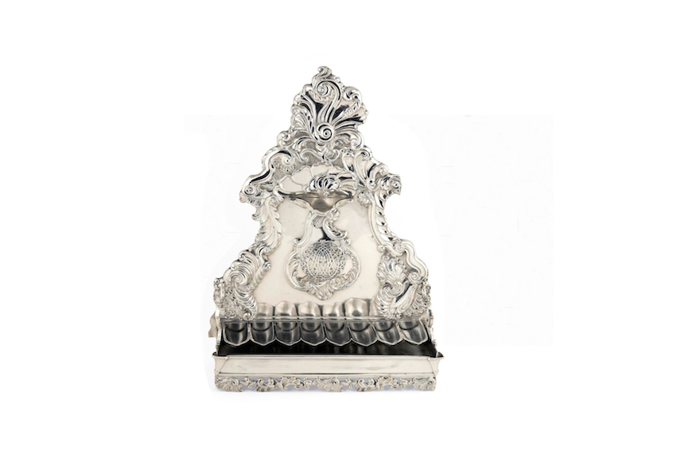
Despite its humble appearance, The Amsterdam Jewish Historical Museum’s Nieuwenhuys menorah is worth more than many of the city’s houses. (Courtesy of the the Amsterdam Jewish Historical Museum)

AMSTERDAM (JTA) — Nothing about the appearance of object MB02280 at this city’s Jewish Historical Museum suggests it is the capital’s priciest Hanukkah menorah, worth more than the average local price of a duplex home.
Shaped like the body of a violin, it is only 16 inches tall. Its base cradles eight detachable oil cups intended to function as candles on Hanukkah, when Jews light candles to commemorate a 167 BCE revolt against the Greeks. They are set against the menorah’s smooth, reflective surface, whose edges boast elaborate rococo reliefs.
But for all its charms, the Nieuwenhuys menorah — its creator was the non-Jewish silversmith Harmanus Nieuwenhuys — doesn’t stand out from the other menorahs on display next to it at the museum. Far from the oldest one there, the menorah certainly doesn’t look like it’s worth its estimated price of $450,000.
The Nieuwenhuys menorah can hide in plain sight because its worth owes “more to its story than to its physical characteristics,” said Irene Faber, the museum’s collections curator.
Made in 1751 for an unidentified Jewish patron, the Nieuwenhuys menorah’s story encapsulates the checkered history of Dutch Jewry. And it is tied to the country’s royal family, as well as a Jewish war hero who gave his life for his country and his name to one of its most cherished tourist attractions.
The price tag of the Nieuwenhuys menorah, which does not have an official name, is roughly known because a very similar menorah made by the same silversmith fetched an unprecedented $441,000 at a 2016 auction. A collector who remained anonymous clinched it at the end of an unexpected bidding war that made international news. It was initially expected to fetch no more than $15,000.
Another reason for the more vigorous bidding: The menorah came from the collection of the Maduros, a well-known Portuguese Jewish family that produced one of Holland’s most celebrated war heroes. The Nazis murdered George Maduro at the Dachau concentration camp after they caught him smuggling downed British pilots back home. In 1952, his parents built in his memory one of Holland’s must-see tourist attractions: the Madurodam, a miniature city.
“I imagine the connection to the Maduro family drove up the price,” said Nathan Bouscher, the director of the Corinphila Auctions house south of Amsterdam, which has handled items connected with famous Dutch Jews.
Besides the menorah on display at the Jewish Historical Museum, the Netherlands has another very expensive one in the Rintel Menorah: A 4-footer that the Jewish Historical Museum bought last year for a whopping $563,000. Far more ostentatious than the modest-looking Nieuwenhuys menorah, the Rintel, from 1753, is made of pure silver and weighs several kilograms. It is currently on loan to the Kroller-Muller Museum 50 miles east of Amsterdam.
The Jewish Historical Museum has no intention of selling the Nieuwenhuys, Faber said, although it could attract even more spectacular bids owing to its provenance: It was bought by the late queen of the Netherlands, Wilhelmina, as a gift for her mother and given to the museum by her great-grandson, King Willem-Alexander.
“We don’t know who commissioned the work, but from the reputation of the artist and the amount of labor it took, it was probably a wealthy Jewish family, perhaps of Sephardic descent,” Faber told JTA last week at the museum.
At the center of the object is a round network of arabesque-like decorations “that probably contains the owner’s initials in a monogram,” Faber said, “but we haven’t been able to decipher it. It’s a riddle.”
The monogram was one of several techniques that Nieuwenhuys and other Christian silversmiths in the Netherlands had developed for their rich Jewish clients.
Before the 19th century, no Jews were allowed to smith silver in the Netherlands because they were excluded from the Dutch silversmiths guilds, which were abolished in the 1800s.
“This exclusion was beneficial [to the guild] because it kept out competition, but it meant that Christian smiths needed to become experts at making Jewish religious artifacts like this menorah,” Faber said.
Works like the menorah on display at the museum illustrate how some Jewish customers clearly were art lovers with sophisticated tastes.
Whereas the Maduro menorah was symmetrical with Baroque highlights, the Nieuwenhuys is asymmetrical with rococo characteristics that were “pretty avant-garde for its time,” Faber said. The smooth surfaces are “another bold choice, showing finesse,” she added.
Whoever owned the menorah no longer possessed it by 1907, when Queen Wilhelmina bought it for an unknown price at an auction to give it as a gift to her mother, Princess Emma.
This purchase may appear inconsequential to a contemporary observer, but its significance becomes evident when examined against the backdrop of institutionalized anti-Semitism among other European royal houses and governments.
The German Emperor Wilhelm II, a contemporary of Wilhelmina, was a passionate anti-Semite who famously said in 1925 that “Jews and mosquitoes are a nuisance that humankind must get rid of some way or another,” adding “I believe the best way is Gas.”
Belgium’s King Leopold III was more politically correct, stating magnanimously in 1942 that he has “no personal animosity” toward Jews, but declaring them nonetheless “a danger” to his country. He raised no objections when the Germans and their collaborators began deporting Belgian Jews to their deaths.
In countless wartime broadcasts, Queen Wilhelmina of the Netherlands rallied the Dutch but mentioned Jews only three times. (National Archive of the Netherlands)
But in the Netherlands, where thousands of Jews found haven after fleeing the Spanish and Portuguese Inquisition of the 16th century, royals not only refrained from such statements but were genuinely “interested in other faiths, including the Jewish one,” Faber said.
Wilhelmina’s gifting of a menorah to her mother “isn’t strange for her,” Faber said. “I imagine she found it fun, something to talk about with her mother, to see together how it works.” After all, “Jews have always been under the protection of the Royal House.”
Except, that is, during the years 1940-45, when Queen Wilhelmina and the Royal House fled to the United Kingdom. Wilhelmina mentioned the suffering of her Jewish subjects only three times in her radio speeches to the Dutch people during five years of exile.

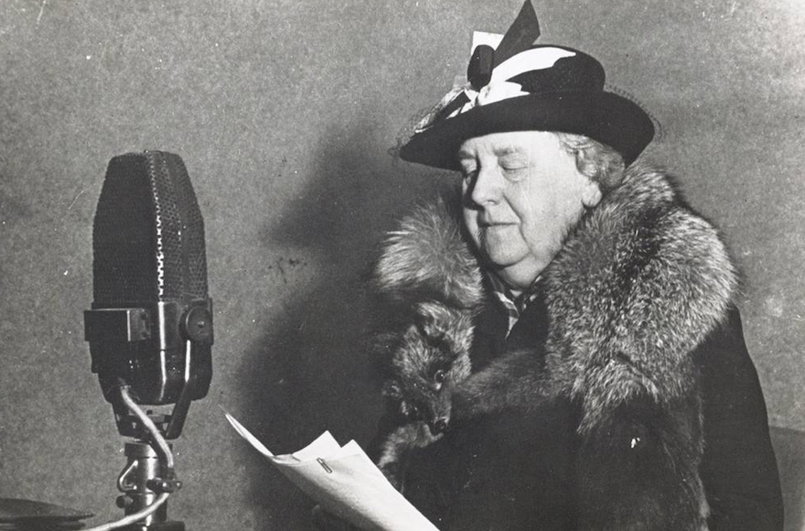

Whereas before the war “Jews always sought the Royal House,” during and after “it appeared Wilhelmina didn’t think too much about the Jews,” Faber said. This was “a stain” on relations between Dutch Jews and the Royal House, which underwent a “rupture.”
But this was gradually healed in the postwar years.
The fact that King Willem-Alexander, Wilhelmina’s great-grandson, in 2012 gave the Nieuwenhuys menorah on an open-ended loan to the Jewish museum on its 90th anniversary “symbolizes the healing of the rupture,” Faber said.
Cnaan Liphshiz Cnaan Liphshiz is based in the Netherlands, where he reports on Jewish life throughout Europe. Born in Israel, he previously worked as foreign news editor for Maariv and as a reporter for Haaretz.

Reprinted from the November 13, 2018 dispatch of the JTA (Jewish Telegraphic Agency.)

Jewish Girl Teaching the Late President George Herbert Walker Bush How to Play with the Hanukah Dreidel
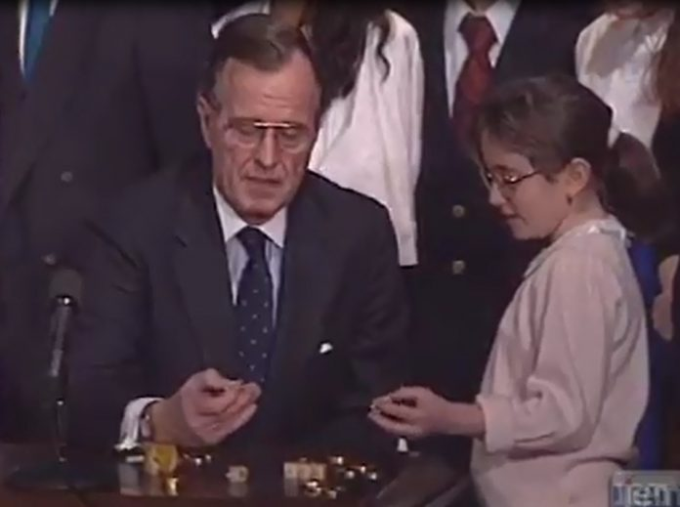

This photo was taken around Chanukah sometime between 1989 -1992. Reprinted from a video of JEM – google When President Bush played dreidel - COLLIVE
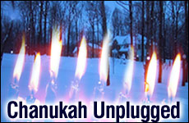
By Carol Tice

Our Chanukah candles shone extra-bright last year. That's because they were the only lights in our house.

The day of Chanukah eve, the Seattle area was visited by a vicious windstorm (officially named "The Chanukah Eve Windstorm" by a National Weather Service contest). About a million homes lost power, including nearly every home on our island of 24,000. Near our home toppled trees blocked roads and beheaded telephone poles left their electric wires in tangles on the ground. Our guess was the power wouldn't be restored anytime soon.
With schools, child care and my work day all canceled and the temperature in the mid-30s, I started planning how to make our first night of Chanukah celebration -- and Shabbat dinner -- without electricity.
Fortunately we have a woodstove and can heat much of our house and cook atop it, so we weren't going to freeze or starve. Milk and other perishables went into coolers on the deck, preserved by the cold outside.
Challah I had baked the week before came out of the rapidly defrosting freezer to be warmed on top of the stove. We wrapped salmon in aluminum foil and baked it on the coals. Gelt and a chocolate orange we'd been given as a gift would be our simple dessert. With store shelves in town rapidly emptying, and warnings to stay off the roads both for safety and to conserve scarce gasoline, we would eat what we had.
I had already gathered the things I needed for Chanukah -- menorah, candles, gelt, dreidels, Chanukah storybooks. There wouldn't be any frying latkes or doughnuts (we couldn't get the oil hot enough on the woodstove), or Chanukah music CDs or Chanukah videos, but we had the basics.
Lighting that tiny Chanukah candle in our cold, darkening kitchen left my two preschoolers in hushed awe. On our wooded street, our neighbors' homes were nearly invisible in the dark. We sang our Chanukah songs without accompaniment -- "Mi Yimalael" (Who Can Retell The Things That Befell Us) was an obvious choice here -- and my three-year-old daughter Ariella even made up a few Chanukah songs of her own.
Seeing those small lights in our darkened home made me feel transported back in time. I understood for the first time, on a deeper level, the small glimmer of hope the Maccabees must have felt lighting the menorah in the restored Temple, praying that somehow their tiny pool of oil would last over a week, until more fuel could be made.
I thought of the simple Chanukahs my great-grandparents likely celebrated back in the pre-electricity days in their small town of Lvov, Poland. Those nights may well have been much like this one, cold and dark, lit only by candles and by the simple joy of celebrating our freedom to worship as Jews.
With our electronic distractions gone, the whole evening seemed to take on a magical, intimate quality.
With our electronic distractions gone*, the whole evening seemed to take on a magical, intimate quality. We told the Chanukah story from memory, huddled together for warmth in the orange glow of the woodstove. My preschoolers were even good sports when their small gifts for the night turned out to be messy modeling clay they couldn't play with until morning brought more light.
As night fell, our lights were increased by Shabbat candles. We ate some of the most delicious tangerines I've ever tasted for our first Shabbat course. Sitting by jet-black windows unlit by street lamps, all agreed this was certainly the most wonderful challah I had ever baked. Each dish tasted exquisite, its warmth an amazing gift.
With our bedrooms closed off and cold, we and our three children talked, cuddled, and played into the night, then curled up on couches and in sleeping bags around the still-warm stove together to spend the night. Our second night of Chanukah passed in much the same way.
A week later, some of our friends still didn't have their power back on, including our rabbi. Some areas of Seattle went two full weeks before power was restored.
We were more fortunate. Though we were braced for an entire Chanukah week without power, our lights came back on just over two days after they'd flickered out.
Moving around my house switching on lights, listening to the comforting sound of my heater warming up, I realized I was living my own miracle of Chanukah -- the miracle of light where I thought there would be none. The miracle of ending up with one of the most memorable Chanukahs my family ever had, despite the hardships.
This year, I'm thinking maybe we'll turn off all the lights and do it all again. I think Chanukah just won't be as inspiring without those tiny candle flames standing brave and alone against the dark.
*Luckily we had the additional light of our woodburning stove as Jewish law prohibits making ordinary use of the light given off by the Chanukah candles.
Carol Tice is a mother of three, reporter and teacher who lives on Bainbridge Island, Wash.

Reprinted from the Aish.com website. Originally published on December 1, 2007.

